import pandas as pd

import pyodbc

try:

    conn = pyodbc.connect(

        'Driver={SQL Server};'

        'Server=DESKTOP-VOT1DO6\MSSQLSERVER_NEW;'

        'Database=HelloWorld;'

        'Trusted_Connection=yes;'

    )

    print("Connection Established")

except Exception as e:

    print("Connection Failed")

# Perform the following operations:

# 1. Write a program that opens the CSV file, reads its records one-by-one, and calls a SQL

#    INSERT statement to insert the rows into a database table.

def quest1():

    # See Oct28

    pass

# 2. Generate a CSV file with 10,000 records of fabricated data from the free Online Data

#    Generator.

#    a. The file is &lt;FILE&gt;.csv .

#    b. It contains the columns ID, Job Title, Email Address, and FirstName LastName.

#    c. A Python program will execute a SQL Server BULK INSERT statement to load data

#    from the file into a table.

def quest2():

    # create table

    cursor = conn.cursor()

    try:

        cursor.execute("DROP TABLE IF EXISTS Load_csv_tb;")

        cursor.execute("""

        CREATE TABLE Load_csv_tb (

            ID INT,

            Job_Title VARCHAR(255),

            Email_Address VARCHAR(255),

            First_Name VARCHAR(255),

            Last_Name VARCHAR(255)

        )

        """)

        print("Table created successfully!!!")

        conn.commit()

    except Exception as e:

        print(e)

    def insertOnlineRecs():

        # insert csv records

        try:

            query = "BULK INSERT Load_csv_tb FROM 'C:/Users/Ezra Muir/Documents/Training-Work/Python/Oct_Learn/Oct31/employee.csv' WITH (FORMAT='csv', FIRSTROW=2)"

            cursor.execute(query)

            print("Bulk insert success!")

            conn.commit()

            cursor.close

        except Exception as e:

            print(e)

    insertOnlineRecs()

# 3. Write a program that opens the SQL server file, reads its records one-by-one, and calls a

#    function to to insert the rows into a CSV file.

def quest3():

    try:

        query3 = pd.read_sql_query('''

        SELECT * FROM Employee_prof

        ''',

        conn)

        df = pd.DataFrame(query3)

        df.to_csv(r'C:/Users/Ezra Muir/Documents/Training-Work/Python/Oct_Learn/Oct31/Output.csv', index=False)

    except Exception as e:

        print(e)

def main():

    # quest2()

    quest3()

if __name__ == "__main__":

    main()

OUTPUTS

Question 1

Question 2

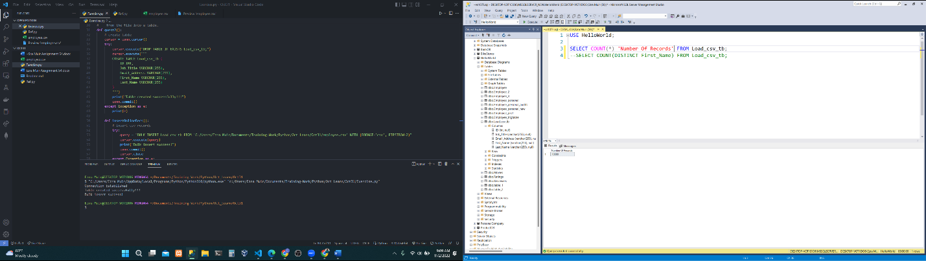

Question 3